Regional anaesthesia in patients on newer Anticoagulants and Antiplatelets
Dr.J.Edward Johnson.M.D.(Anaes),D.C.H. Associate Professor, Dept. of Anaesthesiology, Kanyakumari Govt. Medical College, Asaripallam.
Introduction
The new oral anticoagulants are approved for a variety of clinical syndromes, including the prevention of stroke in atrial fibrillation, acute coronary syndromes, treatment of venous thromboembolism (VTE), and prevention of venous thrombosis after total joint surgery or hip fracture. Traditionally, the incidence of neurologic complications as a result of hemorrhagic complications from neuraxial anesthesia has been estimated to be approximately 1 in 150,000 for epidurals and 1 in 220,000 for spinal anesthetics. ¹ Recent epidemiologic survey suggests that the frequency is increasing and may be as high as 1 in 3000 in some patient populations.
In 2010, the American Society of Regional Anesthesia (ASRA) and the European and Scandinavian Societies of Anaesthesiology published guidelines for regional anaesthesia in patients on anticoagulants.^{2–4} However, several new oral anticoagulants have been approved by the US Food and Drug Administration (FDA) since these guidelines appeared: dabigatran in 2010; rivaroxaban and ticagrelor in 2011; and apixaban in 2012.
Thefollowing will be discussed in this lecture notes:
- Anti-platelet agents:Prasugrel and Ticagrelor
- Anticoagulants: Direct thrombin inhibitor-Dabigatran Factor Xa inhibitors-Rivaroxaban, Apixaban and Fondaparinux
NEW ANTI-PLATELET AGENTS
There are three different classes of platelet-inhibiting drugs:
- Cyclooxygenase-1 (COX-1) inhibitors (aspirin)
- ADP P2Y12 receptor antagonists (thienopyridines)
- Platelet glycoprotein (GP) IIb/IIIa inhibitors
which are mostly used for the prevention and treatment of atherothrombotic disorders.
Aspirin inhibits thromboxane A2 (TXA2) synthase through blockade of the COX-1 enzyme. Picotamide, ramatroban, and ridogrel inhibit both TXA2 synthase and TXA2 receptors.
Among the P2Y12 receptor inhibitors, the group of thienopyridines include ticlopidine, clopidogrel and prasugrel, all of which are orally administered prodrugs leading to irreversible ADP P2Y12 receptor inhibition and block intracellular pathways leading to platelet activation. Non-thienopyridine derivatives including ticagrelor, cangrelor and elinogrel do not require metabolic activation and lead to a reversible P2Y12 receptor inhibition in contrast to thienopyridines.
Aspirin an P2Y12 receptor antagonists have synergistic effects in blocking the final common pathway leading to platelet aggregation represented by GP IIb/IIIa receptor, which may be directly inhibited by intravenous GP IIb/IIIa receptor antagonists(Abciximab, Eptifibatide, and Tirofiban).Cilostazol is an inhibitor of phosphodiesterase (PDE) III, which inhibits platelets through an increase in intraplatelet cAMP levels. E5555 and SCH 530348 are thrombin receptor antagonists that block the PAR-1 subtype.
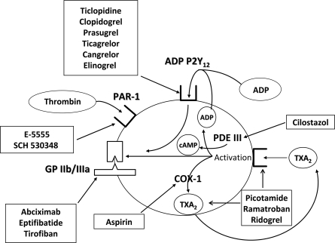
Figure2: Mechanisms of action of antiplatelet agents. (Adapted from Schafer AI: Antiplatelet therapy. Am J Med 101:199–209, 1996.)
Two new antiplatelet agents have recently been approved by NICE for use as part of dual anti-platelet therapy with aspirin. Figure 3
Figure 3: NICE Recommendations for Prasugrel ,Ticagrelor and Clopidogrel are indicated below as part of dual therapy with Aspirin
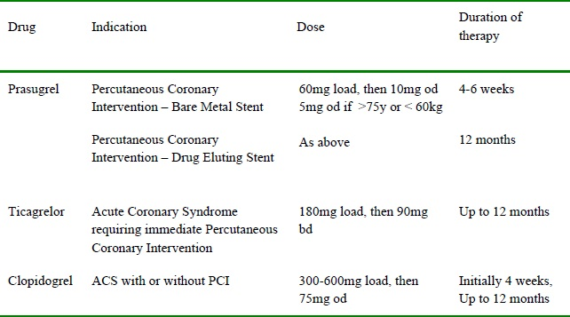
Prasugrel:
Prasugrel is a new thienopyridine, is an orally administered irreversible platelet adenosine P2Y12 receptor antagonist. Prasugrel is a prodrug that first undergoes a rapid de-esterification to an intermediate thiolactone, which is then converted in the liver to the active metabolite by CYP isoenzymes in a single CYP-dependent process. Unlike clopidogrel this is a single step pathway which accounts for its quicker onset of action. Prasugrel's active metabolite appears in the circulation within 15 min after a 60-mg loading dose and reaches maximal plasma concentration at 30 min. In fact, among patients undergoing cardiac catheterization with planned PCI, loading with 60 mg prasugrel resulted in greater platelet inhibition than a 600-mg clopidogrel loading dose.
Compared to clopidogrel, prasugrel exhibits a greater anti-platelet effect (90%inhibition of aggregation in vitro compared to 50%) and much less inter-individual variation in response. Recovery of platelet function takes longer for prasugrel; it takes 7 days for 75% of patients to return to baseline reactivity compared to 5 days with clopidogrel, potentially as a result of the higher degree of platelet inhibition that occurs during treatment⁷⁻⁸. Surgical bleeding is likely to be more troublesome as a consequence.
The prasugrel-induced inhibition of platelet activation is not characterized by the inter individual variability observed for clopidogrel. Recent pharmacogenetic analyses in the TRITON-TIMI 38 trial showed that individuals with the ABCB1 T3435T genotype exhibited reduced platelet inhibition and are at increased risk of recurrent ischemic events during clopidogrel treatment. By contrast, in patients treated with prasugrel, the ABCB1 C3435T polymorphisms were not significantly associated with CV outcomes⁹.
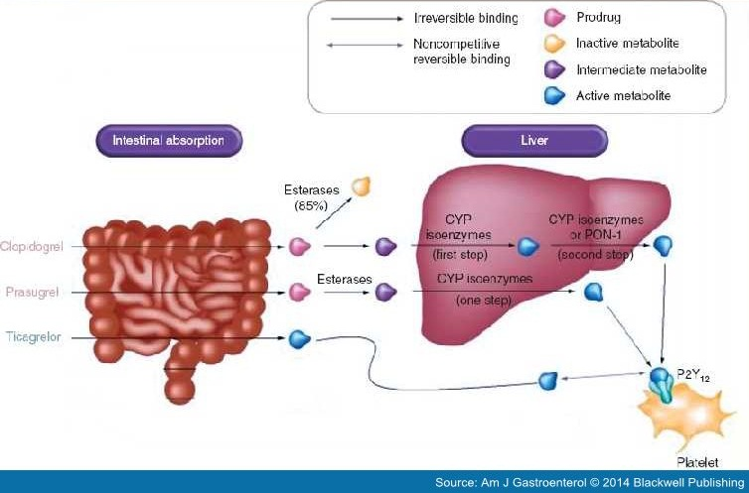
The suggested time interval between discontinuation of thienopyridine therapy and neuraxial blockade is 14 days for Ticlopidine and 7 days for Clopidogrel and Prasugrel.
Reversal Agents: To date, there are no available reversal agents that can be used in the event of an acute bleed in patients on prasugrel. There are several reversal strategies available for patients on antiplatelet therapy who present with a spontaneous or traumatic. These strategies include administration of platelets, desmopressin(0.3 mcg/kg), conjugated estrogens, and/or recombinant factor VII¹⁰.
The present in vivo result showed that platelet transfusion significantly shortened prasugrel-induced prolongation of bleeding time in rats. Prasugrel is an irreversible antiplatelet agent with only transient exposure of platelets to its active metabolite needed for sustained platelet inhibition. At 4 h after the dosing, when maximum inhibition of platelet aggregation was observed in rats, the blood concentration of prasugrel's active metabolite is significantly lower than its peak (Cmax)¹¹⁻¹², thereby allowing transfused platelets to remain functional and provide haemostatic potential.

Ticagrelor
Ticagrelor (AZD 6140) is a nonthienopyridine, direct-acting selective antagonist of the ADP P2Y12 receptor. It is a cyclopentyl-triazolo-pyrimidine, which is administered orally in its active form and does not need the metabolic activation required with thienopyridines. Ticagrelor targets the P2Y12 receptor via a mechanism that is noncompetitive with ADP, suggesting the existence of a binding site on P2Y12 independent to that of ADP. Thus, ticagrelor may act through an allosteric mechanism preventing G-protein-mediated signal transduction following ADP binding to P2Y12¹³.Unlike Clopidogrel and Prasugrel, this inhibition is reversible.
Ticagrelor is metabolized in the liver primarily through CYP3A4/5 iso enzymes. Some of the Ticagrelor metabolites exhibit antiplatelet activity. One of them, AR-C 124910XX, is present at approximately one-third of the plasma concentration of Ticagrelor and has a half-life of approximately 8–12 h.The drug has a rapid offset of action witha half- life of 12 hours, mandating a twice daily dosing regimen (90 mg bd). It too exhibits a greaterlevel of platelet inhibition than Clopidogrel (50-60% in vitro).
In addition to it being a more rapid and more potent platelet inhibitor than Clopidogrel, after drug discontinuation the offset of platelet inhibition is faster for Ticagrelor than for Clopidogrel. The antiplatelet effects of Ticagrelor decline rapidly over 72 h following cessation and near-normal platelet reactivity is achieved after approximately 5 days¹⁴.
Ticagrelor is recommended as a treatment option in conjunction with low dose aspirin for upto 12 months in adults with acute coronary syndrome i.e. STEMI, NSTEMI or unstable angina that cardiologists intend to treat with immediate PCI.
There is a mortality benefit when comparing Ticagrelor with Clopidogrel, but is possible that patients requiring acute surgery who have recently taken Ticagrelor may experience troublesome bleeding andrequire platelet transfusion.
Ticagrelor should be discontinued a minimum of 5 days before any procedure where therapeutic intervention is anticipated or planned.
Platelet transfusion, which is usually proposed to reverse the effect of antiplatelet drugs, has been suggested to be inefficient because circulating Ticagrelor and its active metabolite are likely to inhibit the fresh platelets.

Antiplatelet comparison chart:
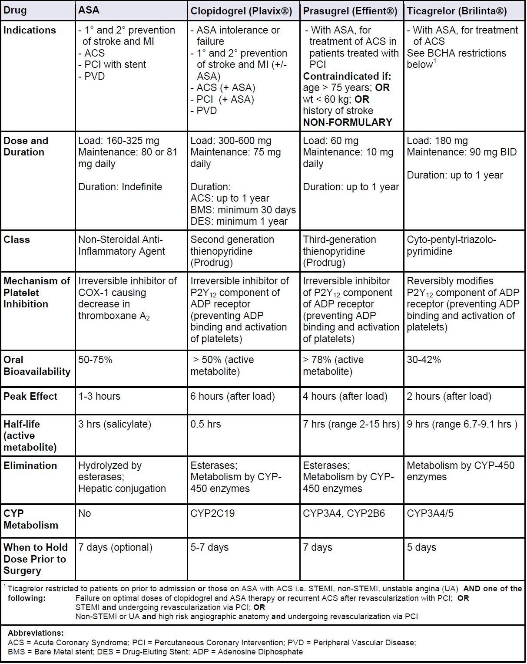

The Coagulation Pathways
Endothelium–platelet interactions and the coagulation cascade serve as the focal points of hemostasis. In primary hemostasis, the endothelium of a damaged vessel releases adenosine diphosphate, serotonin, and thromboxane A2. Platelets respond to these cytokines with expression of glycoprotein IIb/IIIa and platelet–endothelial cell adhesion molecule 1 to form an initial platelet plug. The coagulation cascade unfolds simultaneously with its intrinsic and extrinsic pathways that lead to the formation of fibrin. Figure 1 depicts both the intrinsic and extrinsic pathways that comprise the coagulation cascade.
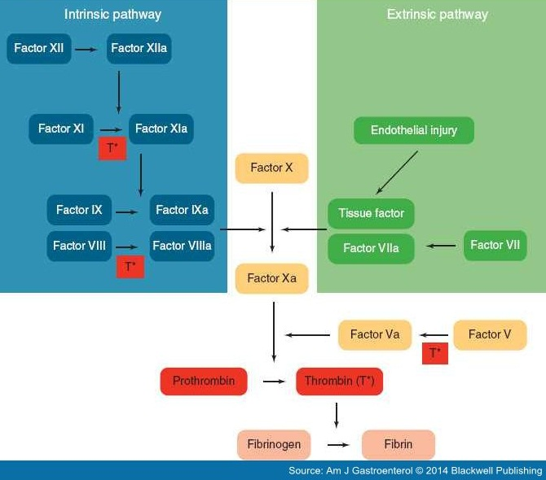

New Oral Anticoagulants (NOACs)
Two classes of New Oral Anticoagulants (NOACs) are currently available, the oral direct thrombin inhibitors (DTIs; e.g., Dabigatran) and oral direct factor Xa inhibitors (e.g.,Rivaroxaban,Aapixaban and Edoxaban). Unlike VKAs, which block the formation of multipleactive vitamin K-dependent coagulation factors (factors II, VII, IX and X), these drugs block the activity of one single step in coagulation.
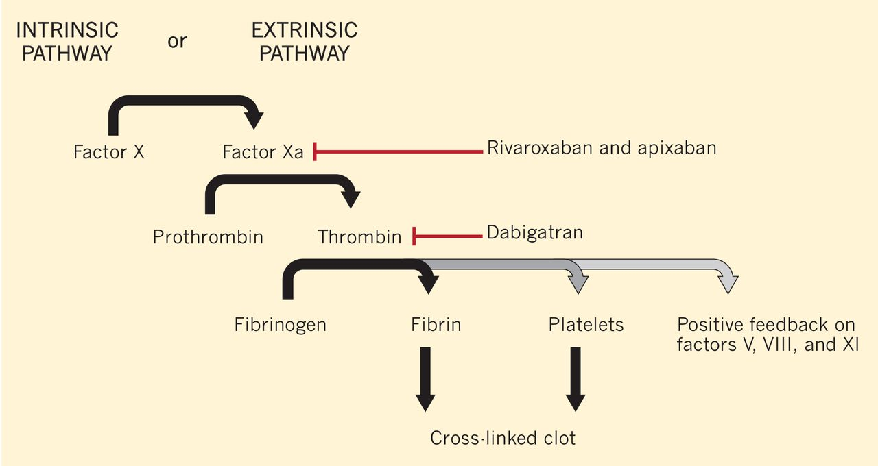
Advantages of these new agents including the uses of fixed-dosing with no need for monitoring, few interactions and a wider therapeutic window counteract with their current drawbacks. At the moment, Rivaroxaban, Dabigatran and Apixaban are approved for antithrombotic prevention in Atrial Fibrillation (AF) by the European Medicines Agency (EMA) and Food and Drug Administration (FDA). Recently, NOACs have been approved for the treatment of Venous Thrombo Embolism (VTE) in phase III clinical trials compared with standard heparin/ VKA regimen.
Dabigatran
Dabigatran etexilate is an orally administered pro-drug of Dabigatran, a reversible thrombin inhibitor. Dabigatran etexilate has a bioavalability of 7.2%. Peak plasma concentrations are attained 1.5–3 h after intake of the pro-drug. It has a half-life of 14–17 h in healthy volunteers. Because Dabigatran is cleared mostly through the kidneys (80%), its elimination half-life is doubled from 14 to 28 hours in patients with end-stage renal disease.The drug is contraindicated in patients with CrCl ,30 ml kg/min. Dabigatran etexilate is a substrate for the transporter P-glycoprotein (P-gp); Dabigatran itself is not. Drugs that inhibit P-gp lead to a higher bioavailability of Dabigatran; as a result a lower dose of Dabigatran is recommended in those patients taking P-gp inhibitors (e.g. Verapamil or Amiodarone).
Thrombin time is a highly sensitive test that has been used to detect the anticoagulant effects of Dabigatran. However, thrombin time is not useful in quantifying the effect because it lacks a linear correlation with Dabigatran drug concentrations. The Ecarin(Ecarin is a commercially available snake venom that converts prothrombin to meizothrombin) Clotting Time, on the other hand, has a linear correlation with Dabigatran concentrations and is considered to be the most sensitive assay for Dabigatran¹⁵. Although activated partial thromboplastin time is prolonged after Dabigatran administration, it lacks a linear correlation. The PT is the least sensitive test.
The 2015 ASRA guidelines for interventional pain procedures recommend an interval equal to 5 half-lives (4-5 days) between drug discontinuation and neuraxial procedures to allow the majority of the drug to be cleared¹⁶.
Recommendations
- Time interval for which Dabigatran needs to be discontinued before neuraxial puncture/catheter manipulation or removal: 4 to 5 days.
- In patients with end-stage renal disease, because the half-life of Dabigatran is around 28 hours, it is advised to wait 6 days before neuraxial intervention.
- Time interval when Dabigatran can be restarted after neuraxial puncture/catheter manipulation or removal: 24 hours. If the risk for VTE is considered to be high, then half the usual drug dose can be administered 12 hours after the procedure.
It is unlikely that fresh frozen plasma is effective in the reversal of Dabigatran. Activated charcoal prevents absorption of the Dabigatran but needs to be given within 2 hours of ingestion of the drug. Dialysis might speed elimination of the drug. Recombinant factor VIIa has been recommended to control hemorrhage. Prothrombin Complex Concentrates (PCCs) or concentrated pooled plasma products contain either 3 (factors II, IX, and X) or 4 (factors II, VII, IX, and X) clotting factors. The use of 4-factor PCCs has been suggested, but may not be able to reverse the anticoagulant effect of Dabigatran. Idarucizumab, a monoclonal antibody fragment, binds Dabigatran with an affinity that is 350 times as high as that observed with thrombin. Consequently, Idarucizumab binds free and thrombin-bound Dabigatran and neutralizes its activity. In healthy young volunteers the administration of Idarucizumab produced immediate and complete reversal of the anticoagulant effects of Dabigatran without procoagulant effects. This is a first FDA approval of a specific reversal agent for a novel oral anticoagulant (NOAC). Idarucizumab will likely correct aPTT and plasma-diluted thrombin time but the correlation of lab results with improved outcomes is not established. Plasma Dabigatran concentrations can increase more than 12-24 hours after Idarucizumab, likely due to re-distribution from the extravascular compartment.The risks and benefits of repeat Idarucizumab administration are not known.
Rivaroxaban
Rivaroxabanis a direct factor Xa inhibitor. Its onset ofaction is rapid and peak plasma concentrations are observedwithin 2.5–4 h. Maximum inhibition of factor Xa, whichranges from22%to 68%, occurs in 3 hrs after dosing and is maintainedfor at least 12 h. Rivaroxaban has a terminal half-life of 5.7–9.2 h, but can be as long as 11–13 h inelderly patients. One-third of the drug is eliminated by the kidneys, one-third by the faecal/biliary route, and one-third is metabolized to inactive metabolites. Renal clearance of rivaroxaban decreases with increasing renal impairment. Because Rivaroxabanis partly metabolized by the liver, its use should be avoided in patients with moderate-to-severe liver disease. Drugs that induce (carbamazepine, phenytoin, andrifampin) or inhibit (ketoconazole and ritonavir) P-glycoproteinand CYP 3A4 should not be given with Rivaroxaban.
It is approved for stroke prevention in AF and for VTE prophylaxis following orthopaedic surgery. It is administered orally and commenced at a dose of 10mg once daily 6-10 hours post-operatively and continued for two weeks post knee replacement and five weeks post hip replacement. When used for prevention of stroke and systemic embolus in patients with AF, 20mg Rivaroxaban once daily is advocated.
Rivaroxaban prolongs the prothrombin time (PT) in a dose-dependent manner, but until further data are available, monitoring with PT is not recommended. The anti-Factor Xa chromogenic assay is the most suitable assay for the quantitative assessment of Rivaroxaban. If this method is not available or in an emergency situation, such as before urgent surgery, the PT assay (expressed in seconds) using a thromboplastin reagent sensitive to Rivaroxaban may be useful to indicate whether the anticoagulant effect of Rivaroxaban is present¹⁷. There is no specific antidote available.
The Scandinavian Society guidelines recommend a minimum of 18 h between the last dose of Rivaroxaban and removal of an indwelling catheter, and a minimum of 6 hbefore the next dose^{18.} The European Society guidelines recommend an interval of 22–26 h between the last dose of Rivaroxaban and removal of an indwelling catheter, probably based on the prolonged half-life of Rivaroxaban in elderly patients (11–13 h), and an interval of 4–6 h between epidural catheter removal and the next dose of Rivaroxaban¹⁹.
The 2015 ASRA guidelines for interventional pain procedures recommend an interval equal to 5 half-lives (3 days) between drug discontinuation and neuraxial procedures, to allow for the majority of the drug to be cleared. These guidelines recommend delaying resumption of Rivaroxaban 24 hours after the intervention to account for its short onset of effect (2.5-4 hours), unless the VTE risk is high.
Recommendations
- Time interval for which Rivaroxaban needs to be discontinued before neuraxial puncture/catheter manipulation or removal: 3 days.
- Time interval when Rivaroxaban can be restarted after neuraxial puncture/catheter manipulation or removal: 24 hours. If the risk for VTE is considered to be high, then half the usual drug dose can be administered 12 hours after the procedure.
Apixaban
Apixaban is an orally administered, reversible, direct factor Xa inhibitor, similar to Rivaroxaban. Its bioavailability, when administered orally, ranges from 51% to 85%, and peak concentrations are achieved within 1 to 2 hours. When Apixaban is administered twice daily, steady state is reached in about 3 days. Its half-life is between 10 and 15 hours, and elimination occurs through multiple pathways, with 25% of the drug excreted by the kidneys and 75% by liver and biliary metabolism, as well as intestinal excretion. Apixaban is also a substrate for both P-gp and CYP3A4.
Apixaban has been shown to be as effective as LMWH for the treatment of acute VTE, with significantly less bleeding risk.
The aPTT is not an appropriate test for monitoring factor Xa inhibitors, and Apixaban has little effect on the PT.The dilute PT assay, where in the thromboplastin reagent is diluted 16 times,has improved sensitivity over the conventional PT. Apixaban can be evaluated with the anti-Xa assay. The anti-Xa assay is more sensitive than the PT and as sensitive as the dilute PTassay, and seems to be the best choice for clinical monitoring of the anticoagulant effect of Apixaban. Activated charcoal, given within3 hours of ingestion, reduces the absorption of Apixaban. Whether PCCs would be effective in controlling bleeding due to Apixaban has not been adequately assessed.
Recommendations
- Time interval for which Apixaban needs to be discontinued before neuraxial puncture/catheter manipulation or removal: 3 to 5 days.
- Time interval when Apixaban can be restarted after neuraxial puncture/catheter manipulation or removal: 24 hours. If the risk for VTE is considered to be high, then half the usual drug dose can be administered 12 hours after the procedure.

Management of patients presenting for elective surgery
Published guidelines have differing recommendations on the safe interval between discontinuation of the anticoagulant and performance of neuraxial procedures and between the interventional procedure and redosing of the drug. While two to three half-life intervals might be acceptable in patients who are at high risk for VTE or stroke, an interval of four to six half-lives between discontinuation of the drug and neuraxial injections is probably safer in most patients at low risk of thrombosis.In those with renal disease, the interval lshould be based on creatinine clearance. After a neuraxial procedure or removal of an epidural catheter, anticoagulants can be resumed within 24–48 h in mostpatients, but they can be taken sooner in patients who are at higher risk for VTE or stroke, that is, 24 h minus the time to peak effect of the drug. The new antiplatelet drugs Prasugrel and Ticagrelor should be stopped 7 or 5 days, respectively, before aneuraxial injection and can be restarted 24 h later.
Currently, it is generally recommended that patients with the highest risk of arterial or venous thromboembolism, who require interruption of oral anticoagulant therapy for surgery, should receive therapeutic-dose heparin therapy (eg, unfractionated heparin [UFH], low molecular weight heparin [LMWH]) during much of the interval when the international normalized ratio (INR) is subtherapeutic.
ANTICOAGULANTS | Timing of spinal needle insertion or epidural catheter placement in a patient who has been given an anticoagulant | Catheter manipulation in the presence of anticoagulation | Minimum time between epidural catheter insertion or removal and administration of anticoagulant
Dabigatran | Stop Dabigatran 4 to 5 days prior to insertion.  Renal diseases 6 days | Caution: avoid any catheter manipulation while the patient is receiving an anticoagulant | 24 hours
Rivaroxaban | Stop Rivaroxaban at least 3 days prior to insertion.  Consider stopping at least 4 days prior if patient has impaired renal function or age greater than 65. | Caution: avoid any catheter manipulation while the patient is receiving an anticoagulant | 24 hours
Apixaban | Stop Apixaban at least 3-5 days prior to insertion.  -CrCl greater than 50ml/min: 3 days  -CrCl less than or equal to 50ml/min: 4 days | Caution: avoid any catheter manipulation while the patient is receiving an anticoagulant | 24 hours
ANTIPLATELET
Prasugrel | 7-10 days | CONTRAINDICATED while catheter in place | 24 hours
Ticagrelor | 5 days |  | 24 hours
The above table is based on Guidelines From the American Society of Regional Anesthesia and Pain Medicine, the European Society of Regional Anaesthesia and Pain Therapy, the American Academy of Pain Medicine, the International Neuromodulation Society, the North American Neuromodulation Society, and the World Institute of Pain. Reg Anesth Pain Med 2015;40: 182–212.

MANAGEMENT OF PATIENTS PRESENTING FOR EMERGENCY SURGERY
Good communication between surgical and anaesthetic teams is vital to coordinate optimal timing of surgical intervention. Ideally emergency surgery should be started at least 1-2 elimination half-lives after the last dose of anticoagulant if possible. Few guideline suggests starting surgery>12 hours after Dabigatran, and >24 hours for Rivaroxaban and Apixaban. Conventional coagulation tests give limited information and cannot be used quantitatively to establish anticoagulant effect.²⁰If the APPT is not elevated the effect of Dabigatran is likely to be low. The same applies to Rivaroxaban if the PT is normal but a degree of anticoagulation cannot be excluded.²¹ There is no specific antidote for Rivaroxaban, and Apixaban.

Utility of coagulation assays and reversal of new anticoagulants:
ANTICOAGULANTS | Dabigatran | Rivaroxaban | Apixaban
Recommended  coagulation assay | - Dilute TT, also called TCT—sensitive.  - aPTT—sensitive (relationship notlinear) and readily available.  - ECT—sensitive but not readily  Available.  - Anti-factor II assay | PT  Anti-Xa assay | Anti-Xa assay  Dilute PT
Reversal | Dialysis  Activated charcoal (within 1–2 h of  ingestion)  For life-threatening bleeding or emergency surgery, consider Idarucizumab (Praxbind) 5gm IV  . | Activated  charcoal (within 8  h of ingestion)  Consider 4-factor PCC (KCentra) 50 units/kg (maximum 5000 units)  (25 unit/kg, maximum 2500 units for intraparenchymal hemorrhage)  NOTE:PCC may partially correct PT/aPTT but will not affect anti-factor Xa activity and will not increase drug clearance; correlation of shortening PT/aPTT with reduction in bleeding risk is unknown | Activated  charcoal  (within 3 h of  ingestion)  Consider 4-factor PCC (KCentra) 50 units/kg (maximum 5000 units)  (25 unit/kg, maximum 2500 units for intraparenchymal hemorrhage)  NOTE: PCC may partially correct PT/aPTT but will not affect anti-factor Xa activity and will not increase drug clearance; correlation of shortening PT/aPTT with reduction in bleeding risk is unknown.
ANTIPLATELETS | Prasugrel | Ticagrelor
Recommended  coagulation assay | - P2Y12 assay.  - Platelet mapping  portion of the TEG.  - Multiple electrode  platelet  aggregometry  (Multiplate) | - P2Y12 assay.  - Platelet mapping  portion of the TEG.  - Multiple electrode  plateletaggregometry  (Multiplate)
Reversal | Platelets | Platelets
PCC, prothrombin complex concentrate; PT, prothrombin time; PTT, partial thromboplastin time; TEG, thrombelastography; TT, thrombin time.

Management of Bleeding
There are several reversal strategies available for patients on antiplatelet therapy who present with an acute hemorrhage (spontaneous or traumatic). These strategies include administration of platelets, desmopressin, conjugated estrogens, and/or recombinant factor VII.
Platelet function assays were not routinely performed.
Interpretation of Platelet Function Assays:
Test | Abnormal (“Positive”) | Normal (“Negative”)
Platelet Function Assay  (PFA-100®) | > 180 seconds = abnormal  > 200 seconds = Aspirin effect  > 300 = GP IIb/IIIa inhibitor effect | 63 – 180 seconds*
Platelet Function Assay ASPIRIN  (VerifyNow® Aspirin Assay) | < 550 ARU | ≥ 550 ARU
Platelet Function Assay PLAVIX  (VerifyNow® P2Y12 Assay) | < 194 PRU | 194-419 PRU†
GP IIb/IIIainihibitor = glycoprotein IIb/IIIa, ARU = aspirin reaction units, PRU = P2Y12 reaction units.
Powner DJ, et.al. reviewed the options presently available to reverse antiplatelet agents. Their recommendation was a minimum of 5 units or equivalent of platelets to off-set the effects of routine aspirin or Clopidogrel/Ticlopidine administration. This combined with discontinuation of Aspirin/Clopidogrel/Ticlopidine²².

% added pooled PRP* | Platelet units† | Platelet pools‡
20 | 5 | 1
40 | 10 | 2
50 | 12.5 | 2-3
60 | 15 | 3
PRP = platelet rich plasma – the percent of normal platelets added to the aspirin / clopidogrel patient’s plasma to reverse the effects of anticoagulation
†Platelet units – increased platelet counts by 10,000 µL
‡Platelet pool = 5 platelet units
Use of Desmopressin (DDAVP) in Patients on Anti-Platelet Agents:
With the increasing use of anti-platelet agents such as Clopidogrel and Aspirin, interest has been raised for a potential role of DDAVP in the setting of acute bleeding in these patients. The use of Desmopressin in patients with normal renal function who have active hemorrhage and a history of recent (within the past 7 days) aspirin or Clopidogrel administration is mentioned in a number of review articles, however, there is a paucity of randomized controlled trials evaluating its safety and efficacy in this population²³
Treatment of bleeding due to Anticoagulants is largely supportive and centers around cessation of drug therapy as these drugs have relatively short half-lives. If bleeding becomes troublesome, local advice is to consider Tranexamic acid(TXA), Prothrombin Complex Concentrate (PCC) and recombinant activated factor VII (rFVIIa), butthere is little supporting evidence for this. PCC and rVIIa are pro-coagulant and may lead to an increased risk of arterial thrombosis, particularly in arteriopathic patients.
Summary of management of bleeding ^{24,25}

- Multidisciplinary approach
- Withhold drug-maybe sufficient for mild bleeding
- General haemostatic and resuscitation measures: large bore iv access, bloods and clotting assays,mechanical pressure, fluid and / or blood administration
- Mild: as above plus TXA 15-25mg/kg orally
- Moderate - severe: as general plus FFP 20 ml/kg + platelet transfusion (if < 70 x109/L), TXA15mg/kg iv, consider PCC, e.g. Octaplex® 30iu/kg(a)
- Life-threatening: as above plus PCC; consider charcoal (if within 2 hours of drug administration) CVVHF for dabigatran

Octaplex ® is a second generation human prothrombin complex concentrate.
Abbreviations: TXA: tranexamic acid. FFP: fresh frozen plasma, PCC: prothrombin complex concentrate, CVVHF:
Continuous veno-venohaemofiltration

Conclusions
The use of anticoagulant and antiplatelet agents has been increasing, primarily as a result of improved life expectancy, the aging population, prevalence of cardiovascular disease, and expansion of indications for more potent, newer anticoagulants. New guidelines are emerging for safe perioperative management of patients on anticoagulant/antiplatelet agents with regard to regional anesthesia.The knowledge of drug pharmacology is the basis for establishing a safe time interval for performance of regional anesthesia.It is important that the decisions to discontinue and restart anticoagulants/antiplatelet agents be made after careful assessment of the risks of discontinuation (thrombosis risk) and continuation (bleeding risk). It is recommended that this be a shared decision-making process with the patient’s treating physician(s).
Ref:
1. Tryba M. Epidural regional anesthesia and low molecular heparin: Pro [in German]. AnasthesiolIntensivmedNotfallmedSchmerzther. 1993;28(3):179-181.
2. HorlockerTT,Wedel DJ, Rowlingson JC, et al. Regional anesthesia in the patient receiving antithrombotic therapy or thrombolytic therapy: American Society of Regional Anesthesia and Pain Medicine evidence-based guidelines (third edition). RegAnesth Pain Med 2010; 35: 64–101
3. Gogarten W, Vandermeulen E, Van Aken H, Kozek S, Llau JV, Samama CM, European Society of Anaesthesiology. Regional anaesthesia and antithrombotic agents: recommendations of the European Society of Anaesthesiology. Eur J Anaesthesiol 2010; 27: 999–1015
4. Breivik H, Bang U, Jalonen J, Vigfusson G, Alahuhta S, Lagerkranser M. Nordic guidelines for neuraxial blocks in disturbed haemostasis from the Scandinavian Society of Anaesthesiology and Intensive Care Medicine. ActaAnaesthesiolScand 2010; 54:16–41
5. Clemetson KJ. Platelets and primary haemostasis.Thromb Res 2012; 129:220–224.
6. Garner A, Pallister CJ, Watson M. Haematology, second edn. Scion Publishing Limited: Banbury, UK, 2010.
7. Price MJ, Walder JS, Baker BA, Heiselman DE, Jakubowski JA, Logan DK et al. Recovery of platelet function after discontinuation of Prasugrel or Clopidogrel maintenance dosing in aspirin treated patients with stable coronary disease. J Am CollCardiol. 2012; 59(25):2338-2343
8. Horlocker TT. Regional anaesthesia in the patient receiving antithrombotic and antiplatelet therapy. BJA 2011; 107 (S1): i96-i106
9. Mega JL, Close S, Wiviott SD et al. Genetic variants in ABCB1 and CYP2C19 and cardiovascular outcomes after treatment with clopidogrel and prasugrel in the TRITON–TIMI 38 trial: a pharmacogenetic analysis. Lancet 376, 1312–1319 (2010).
10. McMillian WD, Rogers FB. Management of prehospital antiplatelet and anticoagulant therapy in traumatic head injury: a review. J Trauma. 2009;66:942-50.
11. Sugidachi A, Ogawa T, Kurihara A, Hagihara K, Jakubowski JA, Hashimoto M, et al. The greater in vivo antiplatelet effects of prasugrel as compared to clopidogrel reflect more efficient generation of its active metabolite with similar antiplatelet activity to that of clopidogrel's active metabolite. J ThrombHaemost. 2007;5:1545–
12. 1551Hagihara K, Kazui M, Ikenaga H, Nanba T, Fusegawa K, Takahashi M, et al. Comparison of formation of thiolactones and active metabolites of prasugrel and clopidogrel in rats and dogs. Xenobiotica. 2009;39:218–226.
13. Storey RF. Pharmacology and clinical trials of reversibly-binding P2Y12 inhibitors. Thromb.Haemost.105, S75–S81 (2011).
14. Gurbel PA, Bliden K, Butler K et al. Randomized double-blind assessment of the ONSET and OFFSET of the antiplatelet effects of ticagrelor versus clopidogrel in patients with stable coronary artery disease: the ONSET/OFFSET study. Circulation 120, 2577–2585 (2009).
15. Tripodi A. The laboratory and the direct oral anticoagulants.Blood. 2013;121(20):4032-4035
16. Narouze, Samer MD, PhD et.al. Interventional Spine and Pain Procedures in Patients on Antiplatelet and Anticoagulant Medications: Guidelines From the American Society of Regional Anesthesia and Pain Medicine, the European Society of Regional Anaesthesia and Pain Therapy, the American Academy of Pain Medicine, the International Neuromodulation Society, the North American Neuromodulation Society, and the World Institute of Pain.Regional Anesthesia & Pain Medicine: May/June 2015 - Volume 40 - Issue 3 - p 182–212.
17. Meyer Michel Samama et.al. Laboratory assessment of rivaroxaban: a review. Thrombosis Journal201311:11.
18. Breivik H, Bang U, Jalonen J, Vigfusson G, Alahuhta S, Lagerkranser M. Nordic guidelines for neuraxial blocks in disturbed haemostasis from the Scandinavian Society of Anaesthesiology and Intensive Care Medicine. ActaAnaesthesiolScand 2010; 54: 16–41.
19. Gogarten W, Vandermeulen E, Van Aken H, Kozek S, Llau JV, Samama CM, European Society of Anaesthesiology. Regional anaesthesia and antithrombotic agents: recommendations of the European Society of Anaesthesiology. Eur J Anaesthesiol 2010; 27: 999–1015.
20. Gogarten W, Vandermeulen E, Van Aken H, Kozek S, Llau J V, Samama C. Regional anaesthesia and antithrombotic agents: recommendations of the European Society of Anaesthesiology. Eur J Anaesthesiol 2010; 27: 999-1015.
21. Gulseth MP, Wittkowsky AK, Fanikos J, Spinler SA, Dager WE. DabigatranEtexilate in Clinical Practice. Pharmacotherapy 2011;31(12):1232-1249.
22. Powner DJ, Hartwell EA, Hoots WK, et.al. Counteracting the effects of anticoagulants oand antiplatelet agents during neurosurgical emergencies.Neurosurgery.2005; 57:823-31.
23. Beshay JE, Morgan H, Madden C, et.al.Emergency reversal of anticoagulation and antiplatelet therapies in neurosurgical patients.J Neurosurg.2010; 112:307-18.
24. Baglin T, Keeling D, Kitchen S. Effects on routine coagulation screens and assessment of anticoagulant intensity in pateints taking oral dabigatran or rivaroxaban: Guidance from the British Committee for Standards in Haematology. Br J Haematol 2012; 159, 427-429
25 Fawole A, Daw HA, Crowther M. Practical management of bleeding due to the anticoagulants dabigatran, rivaroxaban and apixaban. CCJM 2013;vol 80 7 433-451

